Book II: Oikos
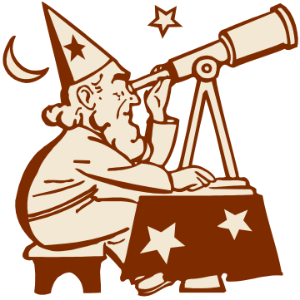

As you can see, this is the second of the two books that comprise my portfolio. Book II is intended to cover the private aspects of my life (i.e. just about everything that is not directly related to school). The sections included in this book are General & Miscellaneous, Hobbies & Interests, and Philosophy & Personal Outlook. Once again, a number of you may already be familiar with some of this information, but it is my hope that each of you will learn something new about me from your reading. And if you’ve been missing all the interesting Quotes, Personality Analyses, etc. that I promised you, fear not. They’re all in here.
As you will note, Book II actually contains more information than does Book I. This is because, as a somewhat introverted person, I tend to view people as being dominated by their personal, rather than their public worlds. Indeed, it often seems to me that we lose track of the real person if we focus too much on what they do when they are around other people and not enough on what they do when they are alone.

